**P3.2.2** Write a recursive function

$function [x,y,s] = pwCAdapt\left(fname, fpname,L,fL,DfL,R,fR,DfR,delta,hmin\right)$ analogous to $pwLAdapt$. Use the same interval acceptance tests as in $pwLAdapt$. The string $fpname$ is name of the derivative function.

Use both $pwLAdapt$ and $pwCAdapt$ to produce approximations to $f(x)=\sqrt[2]{x}$ on the interval $[.001, 9]$. Fix ${ h}_{min}=.001$. Print a table that shows the number of partition points computed by $pwLAdapt$ and $pwCAdapt$ for.

+ Function $pwCAdapt$:

function [x,y,s] = pwCAdapt(fname,fpname,L,fL,DfL,R,fR,DfR,delta,hmin)

% [x,y,s] = pwCAdapt(fname,fpname,L,fL,DfL,R,fR,DfR,delta,hmin)

% Adaptively determines interpolation points for a piecewise cubic hermite

% approximation of a specified function.

%

% fname is a string that specifies a function of the form y = f(u).

% fpname is a string that names a function that is the derivative of f.

% L is real and fL = f(L) and DfL = f'(L).

% R is real and fR = f(R) and DfR = f'(R).

% delta is a positive real

% hmin is a positive real

%

% x is a column n-vector with the property that

% L = x(1) < ... < x(n) = R

% each subinterval is either <= hmin in length or

% has the property that at its midpoint m, |f(m) - q(m)| <= delta,

% where q(x) is the cubic hermite interpolant of (L,fL,DfL) and (R,fR,DfR).

%

% y is a column n-vector with the property that y(i) = f(x(i)).

%

% s is a column n-vector with the property that s(i) = f'(x(i)).

if (R-L) <= hmin

% Subinterval is acceptable

x = [L;R];

y = [fL;fR];

s = [DfL;DfR];

else

mid = (L+R)/2;

fmid = feval(fname,mid);

% Compute the cubic hermite interpolant and evaluate at the midpoint:

% function HCubic in page 117

[alfa,beta,gamma,eta] = HCubic(L,fL,DfL,R,fR,DfR);

% function pwCEval in page 119 and 120

qeval = pwCEval(alfa,beta,gamma,eta,[L;R],mid);

if abs(qeval - fmid) <= delta

% Subinterval acceptable

x = [L;R];

y = [fL;fR];

s = [DfL;DfR];

else

% Produce left and right partitions, then synthesize without

% redundancy.

smid = feval(fpname,mid);

[xLeft,yLeft,sLeft] = pwCAdapt(fname,fpname,L,fL,DfL,mid,fmid,smid,delta,hmin);

[xRight,yRight,sRight] = pwCAdapt(fname,fpname,mid,fmid,smid,R,fR,DfR,delta,hmin);

x = [ xLeft;xRight(2:length(xRight))];

y = [ yLeft;yRight(2:length(yRight))];

s = [ sLeft;sRight(2:length(sRight))];

end

end

+ Script P3_2_2

% P3.2.2

% Compare pwLAdapt and pwCAdapt on f(x) = sqrt(x) on [.001, 9]

% dfdx(x) = .5./sqrt(x)

hmin = .001;

L = .001; fL = f(L); DfL = dfdx(L);

R = 9.000; fR = f(R); DfR = dfdx(R);

disp(' pwL pwC')

disp(' delta length(x) length(x)')

disp('--------------------------------------')

close all

for delta = [.1 .01 .001 .0001 .00001]

[xl,yl] = pwLAdapt('f',L,fL,R,fR,delta,hmin);

nL = length(xl);

[xc,yc,sc] = pwCAdapt('f','dfdx',L,fL,DfL,R,fR,DfR,delta,hmin);

nC = length(xc);

fprintf(' %7.5f %3.0f %3.0f\n',delta,nL,nC);

figure

plot(xl,yl,'ro',xc,yc,'*')

legend('Linear','Cubic',2)

pause

end

+ Result:

>> p3_2_2

pwL pwC

delta length(x) length(x)

--------------------------------------

0.10000 7 9

0.01000 17 12

0.00100 51 15

0.00010 159 25

0.00001 470 42

Last figure:

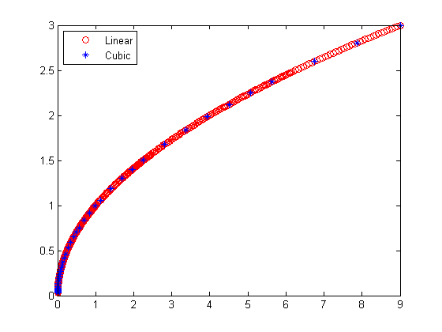

**P3.3.9** Complete function:

+ Function $SmallSpline\left(z,y\right)$:

function [a,b,c,d] = SmallSpline(z,y)

% z is a scalar and y is 3-vector

% a,b,c,d are column 2-vectors with the property that if

%

% S(x) = a(1) + b(1)(x-z) + c(1)(x-z)^2 + d(1)(x-z)^3 on [z-1,z]

% and

% S(x) = a(2) + b(2)(x-z) + c(2)(x-z)^2 + d(2)(x-z)^3 on [z,z+]

% then

% (a) S(z-1) = y(1), S(z) = y(2), S(z+1) = y(3),

% (b) S''(z-1) = S''(z+1) = 0

% S'(x) = 0 + b(1) + 2c(1)(x-z) + 3d(1)(x-z)^2

% S''(x) = 0 + 0 + 2c(1) + 6d(1)(x-z)

% (c) S, S', and S'' are continuous on [z-1,z+1]

% => must be continuous on x = z

S = zeros(8,1);

% S(z-1) = a(1) - b(1) + c(1) - d(1) = y(1)

T = [1 -1 1 -1 0 0 0 0];

S(1) = y(1);

% S(z) = a(1) + 0 + 0 + 0 = y(2)

T = [T ; 1 0 0 0 0 0 0 0];

S(2) = y(2);

% S(z+1) = a(2) + b(2) + c(2) + d(2) = y(3)

T = [T; 0 0 0 0 1 1 1 1];

S(3) = y(3);

% S''(z-1) = 0 + 0 + 2c(1) - 6d(1) = 0

T = [T; 0 0 2 -6 0 0 0 0];

S(4) = 0;

% S''(z+1) = 0 + 0 + 2c(2) + 6d(2) = 0

T = [T; 0 0 0 0 0 0 2 6];

S(5) = 0;

% S continuous at x = z, S1(z) = S2(z) => a(1) = a(2) or a(1) - a(2) = 0

T = [T; 1 0 0 0 -1 0 0 0];

S(6) = 0;

% S' continuous at x = z, S1'(z) = S2'(z) => b(1) = b(2) or b(1) - b(2) = 0

T = [T; 0 1 0 0 0 -1 0 0];

S(7) = 0;

% S'' continuous at x = z, S1''(z) = S2''(z) => c(1) = c(2) or c(1) - c(2) = 0

T = [T; 0 0 1 0 0 0 -1 0];

S(8) = 0;

% u = [a(1) b(1) c(1) d(1) a(2) b(2) c(2) d(2)]

u = T\S;

a = u([1 5]);

b = u([2 6]);

c = u([3 7]);

d = u([4 8]);

% Review: z is not used

+ Script P3_3_9:

% Problem P3_3_9

% Illustrate small spline.

y = [-2 ; -10 ; -3];

z = 2;

[a,b,c,d] = SmallSpline(z,y);

xL = linspace(z-1,z)';

zL = xL - z;

CL = ((d(1)*zL + c(1)).*zL + b(1)).*zL + a(1);

xR = linspace(z,z+1)';

zR = xR - z;

CR = ((d(2)*zR + c(2)).*zR + b(2)).*zR + a(2);

plot([xL;xR],[CL;CR],[z-1;z;z+1],y,'ro')

+ Result of running script P3_3_9:

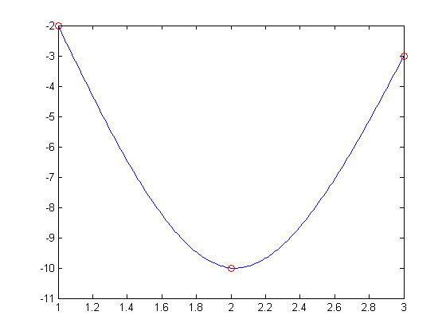

**P3.3.12** Suppose *x* and *y* are column *n*-vectors with $x_{1}<x_{2}<…<x_{n}$. If *z* is a column *m*-vector, then $sval=spline(x,y,z)$ is a column *m*-vector with property that $sval\left(i\right)=S(z_{i})$, where *S* is the not-a-knot spline interpolant of $\left(x_{1},y_{1}\right),…,\left(x_{n},y_{n}\right)$. Let

$S_{1}\left(x\right)$ be the not-a-knot spline interpolant of $sin⁡(x)$ at $x_{i}=\frac{i-1}{10},i=1:21$

$S_{2}\left(x\right)$ be the not-a-knot spline interpolant of $exp⁡(x)$ at $x_{i}=\frac{i-1}{10},i=1:21$

$S_{3}\left(x\right)$ be the not-a-knot spline interpolant of $\sin\left(x\right)∙exp⁡(x)$ at $x_{i}=\frac{i-1}{10},i=1:21$

$S_{4}\left(x\right)$ be the not-a-knot spline interpolant of $2\sin\left(x\right)+3exp⁡(x)$ at $x_{i}=\frac{i-1}{10},i=1:21$

Write a MATLAB script that plots in a single window these four splines across the interval $[0,2]$. The plots should be based one-hundred, equally-spaced evaluations. Avoid unnecessary function calls. You do not have to exploit any trigonometric or exponential identities.

+ Script P3_2_12:

% Problem P3_3_12

% Illustrate not-a-knot spline interpolants using build-in function spline.

% Default: 100 points

z = linspace(0,2);

x = linspace(0,2,21);

y1 = sin(x);

y2 = exp(x);

y3 = y1.*y2;

y4 = 2*y1 + 3*y2;

sval1 = spline(x,y1,z);

sval2 = spline(x,y2,z);

sval3 = spline(x,y3,z);

sval4 = spline(x,y4,z);

plot(z,sval1,'g',z,sval2,'b',z,sval3,'r',z,sval4,'m',x,y1,'go',x,y2,'bo',x,y3,'ro',x,y4,'mo');

hleg = legend('S_1(x) = sin(x)','S_2(x) = e^x','S_3(x) = sin(x) + e^x','S_4(x) = 2sin(x) + 3e^x');

set(hleg,'Location','Best');

+ Result of running script P3_3_12:

